Royal Air Force Benson Weekly Flying Programme

RAF Benson aircraft will be conducting flying activity within the following times:

All times in LOCAL | Available Flying Window
Monday | 0700 - 0300
Tuesday | 0700 - 0300
Wednesday | 0700 - 0300
Thursday | 0700 - 0300
Friday | 0700 - 1715
Saturday | NIL
Sunday | NIL

*Please note these times may be amended without notice owing to operational requirements. Due to operational requirements, we may fly up to 1 hour later than planned to enable training priorities.

The emergency aircraft of the National Police Air Service and Thames Valley Air Ambulance will continue to be permitted to operate 24 hours a day.

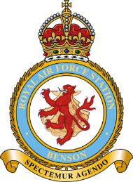
These timings are correct as of 6 Sep 24.

