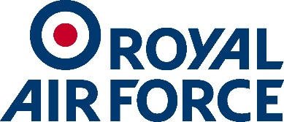

RAF College Heritage Enquiry Form
Thank you for your Enquiry
Please complete and return this form to: CRN-College-HQ-Heritage Enquiries
A member of the College staff will aim to contact you within 30 days
Title: |  | Full Name:
Address:

Postcode: |  | Tel. No.:
E-mail Address:

Enquiry Subject:
eg
General Enquiry
Research

Enquiry:

Do you wish to undertake research in the College Library? | Yes/No/Maybe * Delete as applicable

Please note enquiries regarding Service Records for Royal Air Force personnel should be directed to RAF Disclosures using the following link:
https://www.gov.uk/government/collections/requests-for-personal-data-and-service-records
College Staff Use Only:
Reference Number Allocated

Date Enquiry Acknowledged

Date Enquiry Actioned

Actioned by

Notes

