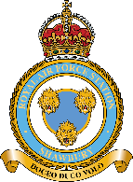
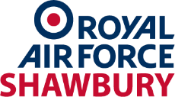
Be Seen, Be Safer 2026(June 26)
Working with the British Horse Society, RAF Shawbury is distributing high visibility clothing in support of the Be Seen, Be Safer campaign. You must ride in Low Flying Area 9, shown by the map below, and have not had items in the past 12 months, please complete the order form to order up to two of each item. Once stock has gone, we are not able to accept any more order forms.
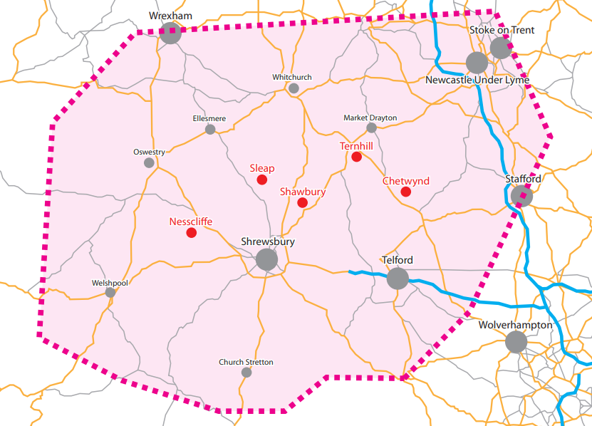

Tabard
The tabards are certified to EN1150 and are fully adjustable to fit over summer and winter clothing, breathable, fluorescent and reflective, stylish as well as practical.

Tabard Size | Chest | Qty
Child/Small Adult | 78cm-104cm
Medium/Large Adult | 84-115cm
XL Adult | 94cm-122cm

Quarter Sheets
The quarter sheets are made from a lightweight, breathable, highly visible mesh and are ideal for both summer and winter use.

Quarter-sheet | Size | Qty
Small | 12.2hh-13.3hh
Medium | 14.00hh-15.1hh
Large | 15.2hh-16.3hh
X-Large | 16.3hh+

Name:
Address:

Email:
Telephone:
Do you ride in Low Flying Area 9?  Have you received any RAF Shawbury High Visibility in the past 12 months:  If yes, what items have you received: | Yes / No  Yes / No

Please return this form by email (preferred) to:

SHY-BeSeenBeSafer@mod.gov.uk

or by post to:
E&M Team, RAF Shawbury, Shrewsbury, SY4 4DZ
Orders will be treated on a first come first served basis, and we do not hold a reserve list.

