  Baggage
  HAND BAGGAGE
  The hand baggage allowance is 9kgs and limited to 1 piece per passenger, with maximum dimensions of 60 x 53 x 25cm.
  LIQUIDS
  No liquids over 100ml are permitted in hand luggage.
  POWER BANKS
  No more than 2 per passenger.
  Must not exceed an energy value of 100 Wh (watt-hours). The energy value and CE marking must be clearly visible on the casing of the power bank.
  Any power bank where this information is obscured/missing or is more than 100 Wh will not be permitted to travel.
  ELECTRONIC CIGARETTES
  Electronic cigarettes are not permitted to be carried in hold baggage. Electronic cigarettes must be switched off and placed within hand baggage.
  Until further notice the carriage of Vype- e Tank PRO products (all variants) are prohibited by the MoD.
  HOLD (ACCOMPANIED) BAGGAGE
  All hold baggage must be dropped off with Swissport staff at check-in. For Health and Safety reasons, the maximum weight per individual hold bag must not exceed 28 kgs. Dimensions should not exceed 100cm x 60cm x 45cm per piece.
  BAGGAGE ENTITLEMENT
  Your allowance is on your passenger itinerary.
  EXCESS BAGGAGE CHARGE PAYMENT
  Excess baggage will only be accepted if annotated on the booking. If over the stated allowance, baggage will be rejected or the passenger will be liable for a charge.
  Contact Details
  Flights timings can change at very short notice due to unforeseen circumstances. Updated booking, check-in and reporting information will be promulgated via the RAF Mount Pleasant and RAF Brize Norton passenger information pages.
  Passengers must check the information websites, which will contain flight details for EMA at least 24 hours prior to beginning their journey.
  Contact details for East Midlands Airport (EMA) – Civil Airhead Duties (CAD) Flight:
  Telephone: 07975 237236 (Not 24 hours)
  Email: Nor-OpsCAD@mod.gov.uk
  Contact details for RAF Mount Pleasant (MPN):
  Telephone: 0050 076442 (Not 24 hours)
  Contact details for Ascension Island Base (ASI):
  Telephone: 002476 63316 (Not 24 hours)
  If individuals have any problems or need to make further enquiries concerning their flights, they should contact their Unit Admin or Travel Cell who requested the booking in the first instance.
  The end date for Pg MACE is dependent on the completed runway resurface works at RAF Brize Norton and is subject to change.
  Further information is contained within the Passenger Itinerary Ticket (PIT) provided with your booking.
  Op MACE VECTOR
  SOUTH ATLANTIC AIRBRIDGE (SAA)
  25 JUL – 15 NOV 26
  Air Movements Squadron
  RAF Northolt
  Civilian Airhead Detachment
 |  | DRESS  All passengers travelling through EMA must wear civilian attire that is smart, clean, and does not reflect badly on the MoD.  ACCOMMODATION ENTITLEMENT  There is no military accommodation available at EMA. Accommodation should be booked at own or unit cost where appropriate. If entitled, MoD Civil Servants and Service Personnel should book via Amex Global Business Traveller (Amex GBT), and all other passengers via hotels direct.  AMEX GBT  All MoD Civil Servants and Service Personnel travelling on the Cyprus Schedule are to ensure they have their own Amex GBT Account set up prior to travelling.  AMEX Hotel Booking Contact Details:  0207 949 4812  HOTELS  There are seven hotels at EMA Airport.  Leonardo, Premier Inn, Radisson. Holiday Inn Express, Travel Lodge, Crowne Plaza, Hilton.  Details available online and through RAF Movements staff at EMA Airport.  TAXIS  Arrow Cars are the official private hire company Telephone: 01332 814000.  Multiple other companies available, details available online and through RAF Movements staff at EMA Airport.  AIRCRAFT DELAYS  Where an aircraft operating through EMA is delayed, passengers are to follow the direction of RAF Movements staff at EMA.
  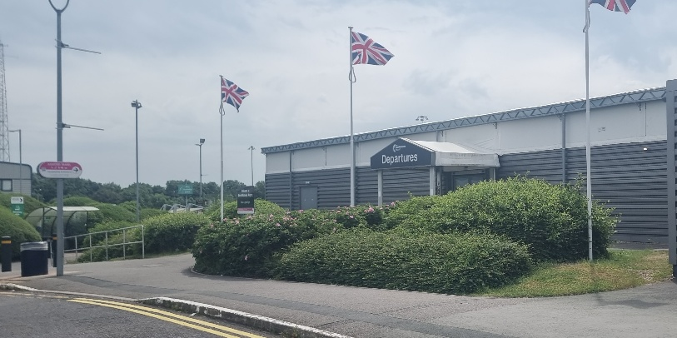
  East Midlands Airport (EMA)
  DIRECTIONS
  East Midlands Airport postcode is DE74 2SA.
  East Midlands Parkway is the closest train station.
  Derby & Nottingham are also near-by.
  East Midlands Airport is easily accessible by using public buses. For advice on planning your journey, visit Traveline.
  HIRE CARS
  Passengers utilising hire cars are responsible for the collection and return of their vehicles to the relevant hire car company. Thrifty does not operate from EMA.
  PARKING
  Short-term car parking is available at EMA at user cost.
  Longer-term parking is available, at user cost, pre-booked via www.eastmidlandsairport.com/parking/
  RESTAURANTS, SHOPS AND CAFÉS
  There is a range facilities at EMA, from vending machines to full restaurants, some offering 24hr service.
  Wi-Fi
  There is a free Wi-Fi facility at EMA.
  SMOKING/VAPING POLICY
  In designated areas outside the terminal building.
  Past Security, there is a designated area on the upper floor of the main Departure Lounge.
  CHECK-IN
  Check-in areas will be clearly advertised on EMA information screens and are accessed through the Departure area shown in the image overleaf.
  Check-in desks open 5 hours before flight departure and then CLOSE 2.5 hours before flight departure.
  FLIGHT SHUT OUT
  Flight shut out is 2.5hrs prior to departure.
  Passengers who arrive late will be refused travel.
  Should passengers be delayed for any reason, they must contact the RAF Movements staff.
  All passengers are encouraged to arrive at the start of the check-window (5hrs pre-ETD) to reduce excessive queuing times.
  WEAPONS HANDLING
  ATLO staff will be positioned at the front of the terminal check-in area for weapons processing.
  VIPS
  No VIP facilities will be provided at EMA.
  Any use of airport lounge facilities is at personal expense.
  BABY CHANGING FACILITIES
  Rooms available prior and post security.
  MULTI-FAITH PRAYER ROOM
  Rooms available prior and post security.
  ALCOHOL AND PASSENGER CONDUCT
  Personnel travelling on duty are not to consume alcohol. All passengers must be fit to fly. Intoxicated, disorderly or impaired passengers will be denied boarding or removed. Fare Paying Passengers will not be refunded if refused boarding.

