  Baggage
  HAND BAGGAGE
  The hand baggage allowance is 9kgs and limited to 1 piece per passenger, with maximum dimensions of 60 x 53 x 25cm.
  MODNET PEDS
  All personnel with service issued PEDs are to comply with JSP 440, Leaflet 5B. Individuals should contact section BSyOs for authority and guidance.
  LIQUIDS
  No liquids over 100ml are permitted in hand luggage. The EMA website contains the most up-to-date information.
  POWER BANKS
  Must not exceed an energy value of 100 Wh (watt-hours). The energy value and CE marking must be clearly visible on the casing of the power bank. Any power bank where this information is obscured/missing or is more than 100 Wh will not be permitted to travel.
  ELECTRONIC CIGARETTES
  Electronic cigarettes are not permitted to be carried in hold baggage. Electronic cigarettes must be switched off and placed within hand baggage. Until further notice the carriage of Vype- e Tank PRO products (all variants) are prohibited by the MoD.
  HOLD (ACCOMPANIED) BAGGAGE
  All hold baggage must be dropped off with Swissport staff at check-in. For Health and Safety reasons, the maximum weight per individual hold bag must not exceed 28 kgs. Dimensions should not exceed 100cm x 60cm x 45cm per piece.
  Contact Details
  Flights timings can change at very short notice due to unforeseen circumstances. Updated booking, check-in and reporting information will be promulgated via the RAF Akrotiri and RAF Brize Norton passenger information pages.
  Passengers must check the information websites, which will contain flight details for EMA at least 24 hours prior to beginning their journey.
  Contact details for East Midlands Airport (EMA) – Civil Airhead Duties (CAD) Flight:
  Telephone: 07975 237236
  Email: Nor-OpsCAD@mod.gov.uk
  Contact details for RAF Akrotiri (AKT):
  Telephone: 00357 25276599
  Email:
  bfc-aki-jms-jbcgpmailbox@mod.gov.uk
  or
  bfc-aki-jms-jabc-indggpmailbox@mod.gov.uk
  If individuals have any problems or need to make further enquiries concerning their flights, they should contact their Unit Admin or Travel Cell who requested the booking in the first instance.
  The end date for Pg MACE is dependent on the completed runway resurface works at RAF Brize Norton and is subject to change.
  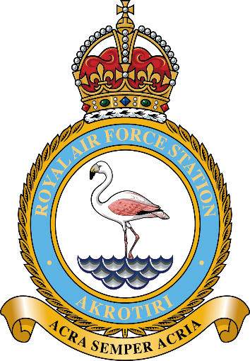
  Programme MACE
  IMPACT OF RUNWAY RESURFACING AT RAF BRIZE NORTON TO CYPRUS AIR TROOPING SERVICE (CATS)
  25 JUL – 15 NOV 26
  Joint Movements Squadron
  RAF Akrotiri
 |  | VIPS  No VIP facilities will be provided at EMA during Pg MACE.  DRESS  All passengers travelling through EMA must wear civilian attire that is smart, clean, and does not reflect badly on the MoD.  CONCESSIONARY PAYMENT  Charges are to be settled at check-in. Payment will be accepted by card only. American Express cards and cash payments are not accepted.  EXCESS BAGGAGE CHARGE PAYMENT  Excess baggage will only be accepted if annotated on the booking. If over the stated allowance, baggage will be rejected or the passenger will be liable for a charge.  FOOD AND BEVERAGES  Security and food and beverage services at EMA close at 2100hrs.  ACCOMMODATION ENTITLEMENT  There is no military accommodation available at EMA. Accommodation should be booked at own or unit cost where appropriate. If entitled, MoD Civil Servants and Service Personnel should book via Amex Global Business Traveller (Amex GBT), and all other passengers via hotels direct.  Amex GBT  All MoD Civil Servants and Service Personnel travelling on the Cyprus Schedule are to ensure they have their own Amex GBT Account set up prior to travelling.  AMEX Hotel Booking Contact Details:  0207 949 4812
  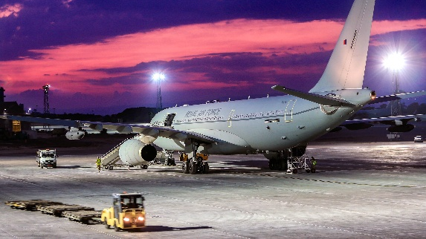
  Programme (Pg) MACE
  The first CATS flight to operate under Pg MACE will be on 25 Jul 26.
  Routine taskings throughout the period of Pg MACE will be:
  Saturdays
  - Depart RAF Akrotiri 1430L
  - Arrive East Midlands Airport 1700L
  Sundays
  - Depart East Midlands Airport 1200L
  - Arrive RAF Akrotiri – 1830L
  Tuesdays
  - Depart RAF Akrotiri 1430L
  - Arrive East Midlands Airport 1700L
  Wednesdays
  - Depart East Midlands Airport 1200L
  - Arrive RAF Akrotiri – 1830L
  ARRIVAL AT EAST MIDLAND AIRPORT
  All passengers are to carry a valid passport, and where appropriate valid visa documentation and/or status card.
  ONWARD TRAVEL
  Passengers from scheduled flights terminating at EMA are to make their own arrangements to proceed to their destination.
  East Midlands Airport (EMA)
  HIRE CARS
  Passengers utilising hire cars are responsible for the collection and return of their vehicles to the relevant hire car company. Thrifty does not operate from EMA. Units are to ensure that the Phoenix Booking System allocates an alternative provider.
  PARKING
  Short-term car parking is available at EMA at user cost.
  CHECK-IN
  Check-in areas will be clearly advertised on EMA information screens.
  Check-in desks will open 5 hours before flight departure and then CLOSE 2.5 hours before flight departure. Passengers will not be processed at EMA prior to the opening of check-in.
  FLIGHT SHUT OUT
  Flight shut out is 2.5hrs prior to departure.
  Failure to check-in for the flight by Flight Shut Out will result in passengers not being boarded. Should passengers be delayed for any reason en-route to the airfield, they should contact the RAF Movements staff as soon as possible.
  All passengers are encouraged to arrive at the start of the check-window (5hrs pre-ETD) to reduce excessive queuing times. Flight timings can change at very short notice due to unforeseen operational reasons. Additional information and an update on live departure timings can be found on the RAF Brize Norton Passenger Information website.
  WEAPONS HANDLING
  ATLO staff will be positioned at the front of the terminal check-in area for weapons processing.

